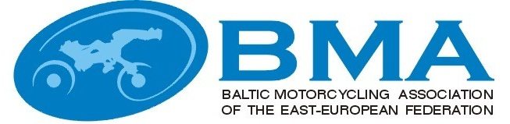

MINUTES
EEBMA TRIAL COMMISSIONS MEETING
Nr.2014-2
Priezkalni, Latvia
06.12.2014
(10:00-12:30)

Participants:

Latvia :
Arturs Grinfelds – BMA trial commission chairman
Egils Agarskis - Vice President EEBMA, guest

Estonia:
Tonis Ross, with mandate of EMF Trial commission

Lithuania:
Julius Simkus, BMA trial commission member
Romas Kazimiraitis organizer, guest

Agenda:

1. Welcome, information from the Chairman.
2. Approval of the Minutes of the previous BMA trial commission meetings.
3. Fallow up on issues from the minutes of the previous meetings.
4. Report from Jury president (Egils Agarskis) about BMA individual and team championships 2014. Approval of the results.
5. Information about FIME trial commission meetings in Krakow and Roma (FIME trial commission member E.Agarskis).
6. Proposals for BMA Trial rules and regulations changes for 2015.
7. 2015 Provisional Calendar.
8. Miscellaneous.

Decisions:

- Mr Grinfelds welcomed everybody to the meeting in Priezkalni.
- The minutes from Jelgava (2013-3) and Minsk (2014-1) were approved.
- All issues to be followed up will be dealt with as questions on the agenda.
- Jury president report for problems, statistics and analysis was heard. The results from the events were approved.
- Egils report on the problems in the work of the World and European Trial commissions, statistic and future visions were listened and taken note of.
- Changes of Baltic Championship regulation for season 2015:
Individual Championship take place in one two days stage in Tapa. The winner is determined by summing the two days penalty points.

Participation fee in 2015 will be 40 EUR, D-Mini, Green 20 EUR for both days and also for riders who participate one day.

To include a new group: Woman’s – participants without age limit after absolute rating if will be participate at least four riders. (cup contest).

Starting numbers regulation - First 10 start numbers for participants allow by the last year place of absolute results of Baltic championship.

One time licenses will be in accordance with the laws and rules of organizer country. Terms and prices should be announced in Competition supplementary regulation.

Sections for motorcycles - Each race must be a minimum of 27 section.

Remove group Free.

Track for the group A will not be made. Group B will be the champion group.

Club Team Championship in next year will not happen.

About Bicycle participation in this competition will be decided after discussion with the organizers and representatives of the Bicycle and resolving the track creation opportunities and the compensation to the organizers, as was the Latvian Championship 2014th

- 2015 season event dates:
Tapa, Estonia - Baltic Individual Championship.
The date will be determined after consultation with the organizer.

NAME: | SIGNATURE:
Artūrs Grīnfelds
Julius Simkus
Tõnis Ross

