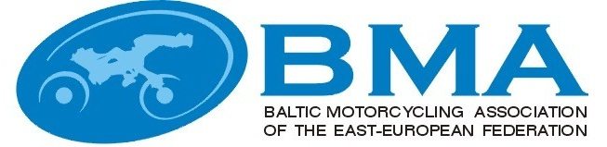

MINUTES
EEBMA TRIAL COMMISSIONS MEETING
Nr.2015-1
e-mail
23-28.01.2015

Participants:

Latvia :
Arturs Grinfelds – BMA trial commission chairman

Estonia:
Ilmar Kald – with mandate of EMF Trial commission

Lithuania:
Julius Simkus, BMA trial commission member

Agenda:

- Aproval of the "Baltic Trial championship rules 2015".

Result of the vote.

Arturs Grinfelds agrees to confirm
Julius Simkus agrees to confirm
Ilmar Kald agrees to confirm

Decisions:

- Approve the "Baltic Trial championship rules 2015"..

NAME: | SIGNATURE:
Artūrs Grīnfelds
Julius Simkus
Ilmar Kald

