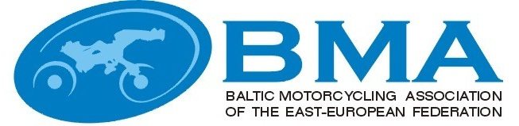

MINUTES
EEBMA TRIAL COMMISSIONS MEETING
Nr.2016-1
e-mail
22.02.2016

Participants:

Latvia :
Arturs Grinfelds – BMA and LaMSF trial commissions chairman

Estonia:
Tōnis Ross – with mandate of EMF Trial commission

Lithuania:
Julius Simkus, BMA trial commission member, LMF Trial commission chairman

Agenda:

- Aproval of the "Baltic Trial championship rules 2016".
- Include in rules point that all participants under 16 years of age (inclusive) must use the back guard.

Result of the vote.

Arturs Grinfelds Q1- Yes, Q2- No, but is possible with the note “recommended”
Julius Simkus Q1- Yes, Q2- No
Tōnis Ross Q1- Yes, Q2-Yes

Decisions:

- Approve the "Baltic Trial championship rules 2015".
- Include in BMA trial ruls TL 01.9.2 point, that for all participants under 16 years of age (inclusive) recommended use the back guard.

NAME: | SIGNATURE:
Artūrs Grīnfelds
Julius Simkus
Ilmar Kald

