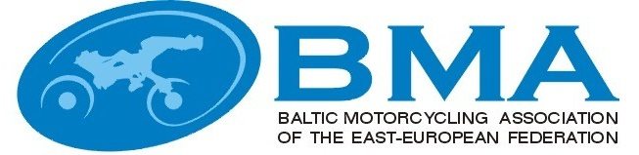

MINUTES
EEBMA TRIAL COMMISSIONS MEETING
Nr.2015-3
Turbas, Latvia
29.11.2015
(09:00-10:00)

Present
Latvia
Arturs Grinfelds – BMA trial commission chairman, Latvian trial commission chairman
Estonia:
Tonis Ross, with mandate of EMF Trial commission
Lithuania:
Julius Simkus, BMA trial commission member, Lituanian trial commission chairman

Quest
Egils Agarskis - Vice President EEBMA, FIME Trial commission member
Voldemars Mateuss – Jury president in Tapa.

Agenda:

1. Welcome, information from the Chairman.
2. Approval of the Minutes of the previous BMA trial commission meeting.
3. Report from Jury president (Voldemars Mateuss) about BMA individual championship 2015. Approval of the results.
4. Information about FIME trial commission meetings in Malta and Roma (FIME trial commission member E.Agarskis).
5. Proposals for BMA Trial rules and regulations changes for 2016.
6. 2016 Provisional Calendar.
7. Miscellaneous.

Decisions:

- Mr Grinfelds welcomed everybody to the meeting in Priezkalni.
- The minutes from Priezkalni (2015-2) were approved.
- Jury president report for problems, statistics and analysis was heard. The results from the events were approved.
- Egils report on the problems in the work of the European Trial commissions, statistic and future visions were listened and taken note of.
- Changes of Baltic Championship rules for season 2016:
Proposals for changes in the rules have not been received.
The main principles remain from the previous year. Follows.
Individual Championship take place in one two days stage in Liepaja. The winner is determined by summing the two days penalty points.

Participation fee in 2016 will be 40 EUR, Mini, Green 20 EUR for both days and also for riders who participate one day.

Starting numbers regulation - First 10 start numbers for participants allow by the last year place of absolute results of Baltic championship.

One time licenses will be in accordance with the laws and rules of organizer country. Terms and prices should be announced in Competition supplementary regulation.

Track for the group A will not be made. Group B will be the championship group.

Club Team Championship in next year will not happen.

Commission agreed trial rules 2016.

- 2016 season event dates:
Liepaja, Latvia - Baltic Individual Championship.
The date will be determined after consultation with the organizer. Provisional end of the season, august.

NAME: | SIGNATURE:
Artūrs Grīnfelds
Julius Simkus
Tõnis Ross

