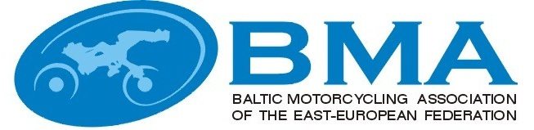

MINUTES
EEBMA TRIAL COMMISSIONS MEETING
Nr.2015-2
Priezkalni, Latvia
07.11.2015
(15:00-16:00)

Present
Latvia
Arturs Grinfelds – BMA trial commission chairman, Latvian trial commission chairman
Estonia:
Tonis Ross, with mandate of EMF Trial commission
Lithuania:
Julius Simkus, BMA trial commission member, Lituanian trial commission chairman

Quest
Egils Agarskis - Vice President EEBMA, FIME Trial commission member

Agenda:

1. Welcome, information from the Chairman.
2. Approval of the Minutes of the previous BMA trial commission meetings.
3. About STOP and NON STOP Trial competition rules.

Q1 Mr Grinfelds welcomed everybody to the meeting in Priezkalni.
Q2 The minutes from Priezkalni (2014-2) and electronic form (2015-1) were approved.
Q3 In current year and also in next year in all Baltic countries national trial championship happened and will happen after Trial Stop Rules.
Also, that we know in Nordic countries and many European countries national championship contrary European championship happen after Stop Rules.
Decision:
To harmonize in Europa European and National trial championships Rules, BMA trial commission decided write letter to FIME to decide for this matter. Also we support FIME trial commission in this matter.
We ask the president of the BMA Nina Birjukova of our commission behalf sign the letter and send it to FIME.

NAME: | SIGNATURE:
Artūrs Grīnfelds
Julius Simkus
Tõnis Ross

